



Certificate of Analysis

RCoA-219/1

|  |  |  |  |
| --- | --- | --- | --- |
|  |  | **10-HC** |  |
| **Client name:** |  | **Specification:** | / |
| **Sample number:** | / | **Storage conditions.:** | Room temperature |
| **Batch number:** | 10-HC-241023 | **Date of Analysis:** | 05.11.2024 |
| **Date of manufacture:** | / | **Raw data:** | RsID: 166890 |
| **Expiration date:** | / | **Analytical technique:** | UPLC – PDA (UV) |

*Limit of quantitation, LOQ = 0.05 w /w %*

|  |  |  |
| --- | --- | --- |
| **Component** | **Assay** | **Unit** |
| CBDV | < LOQ | % as is |
| CBDVA | < LOQ | % as is |
| CBDB | < LOQ | % as is |
| CBD | < LOQ | % as is |
| CBDA | < LOQ | % as is |
| CBG | < LOQ | % as is |
| CBN | < LOQ | % as is |
| CBGA | < LOQ | % as is |
| d9-THC | < LOQ | % as is |
| d8-THC | < LOQ | % as is |
| Sum THC | < LOQ | % as is |
| CBL | < LOQ | % as is |
| CBC | < LOQ | % as is |
| CBT | < LOQ | % as is |
| THCA | < LOQ | % as is |
| CBNP | < LOQ | % as is |
| CBCA | < LOQ | % as is |
| CBLA | < LOQ | % as is |
| 10-OH-HHC | 95.26 | % as is |

|  |  |  |  |  |
| --- | --- | --- | --- | --- |
|  |  | **Name** |  | **Signature** |
| **Author:** |  | Žiga Ogrin, B.Sc., Chemist |  |  |
| **Approved by:** |  | Davor Štirn, Senior Analyst |  |  |

LabCore is European medicines agency accredited CRO – analytical GMP certified (401-11/2022-6). LabCore d.o.o., Dunajska cesta 238e, 1000 Ljubljana, Slovenia, VAT: 90981014, Registration number: 8334625000, email: [info@labcore.eu,](mailto:info@labcore.eu) webpage: [www.labcore.eu](http://www.labcore.eu/)



Page 1 of 2





|  |  |  |  |
| --- | --- | --- | --- |
|  |  | **10-HC** |  |
| **Client name:** |  | **Specification:** | / |
| **Sample number:** | / | **Storage conditions.:** | Room temperature |
| **Batch number:** | 10-HC-241023 | **Date of Analysis:** | 05.11.2024 |
| **Date of manufacture:** | / | **Raw data:** | RsID: 166890 |
| **Expiration date:** | / | **Analytical technique:** | UPLC – PDA (UV) |

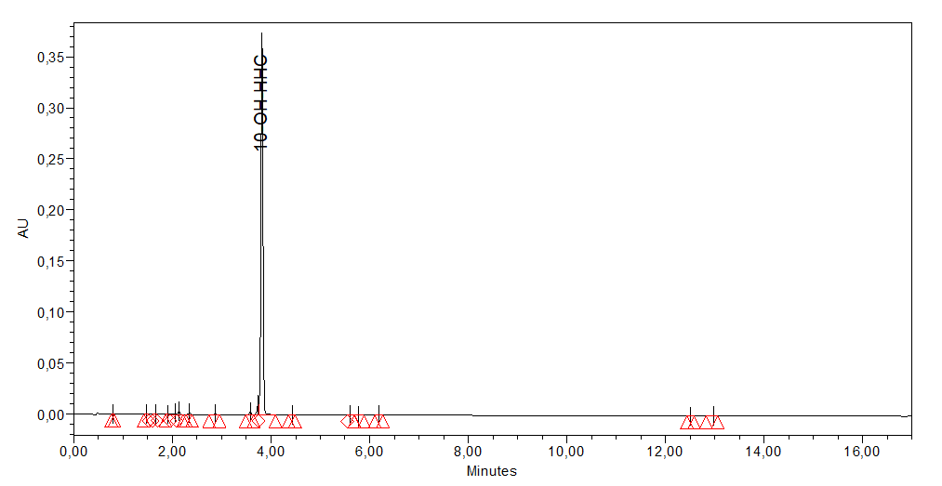

LabCore is European medicines agency accredited CRO – analytical GMP certified (401-11/2022-6). LabCore d.o.o., Dunajska cesta 238e, 1000 Ljubljana, Slovenia, VAT: 90981014, Registration number: 8334625000, email: [info@labcore.eu,](mailto:info@labcore.eu) webpage: [www.labcore.eu](http://www.labcore.eu/)

Page 2 of 2